Arkansas State Pecan Pie Championship
and
Pecan Cooking Contest

The annual Arkansas Pecan Festival and State Pecan Pie Championship will be held Saturday, December 2nd, 2023. The display and judging tents will be on Main St., in the Commercial Historic District of Keo.

10am-11am Entries arrive
12-1pm Judging
1pm Contest results announced & awards presented on the Main stage

General Rules & Information

1. A copy of the recipe must be attached to the dish with name, address, age division and category listed on the 4x6 card. We will be unable to accept the entries if the requested information is not provided.
2. All entries should be cooked and/or ready to eat upon arrival. Food prep at the time of registration is not allowed.
3. No entries accepted that require refrigeration.
4. All entries and recipes become property of the AR Pecan Festival upon entry for future use in an official AR Pecan Festival Cookbook with due credit given to each contestant.

FOOD CATEGORIES for Home Bakers: I. Pecan Pie II. Sweets III. Savory
Age Divisions: I. Age 5-12. II. 13-17 years III. Adult

Professional Bakers: Pecan Pie

Judging
1. Qualified persons will judge the contest.
2. All entries will have identifying information removed before judging.
3. Entries will be judged by food category and assigned a score between 12-1pm.
4. Taste, appearance, flavor, and creativity will be decisive factors in judging.

For information/questions/concerns, please contact: Laura Quinn lauraquinn360@gmail.com or 501.912.2472
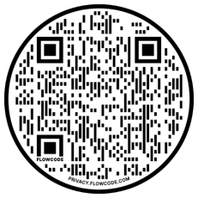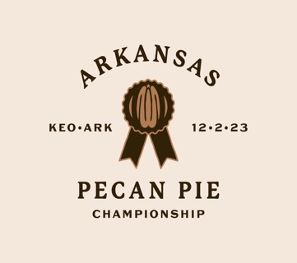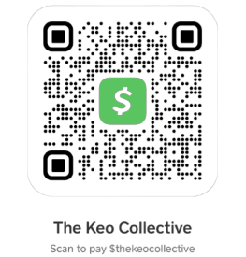
Arkansas State Pecan Pie Championship and Pecan Cooking Contest 2023
Entry Fees: Kids Free!! Home Bakers $10 per entry. Professional Bakers $20 per entry
Name: ____________________________Contestant Number: _______________
Phone Number: __________________________________________________________________
Category: ___________________________________________________________________
Entry Description:_________________________________________________________
______________________________________________________________________________________________________________________________________
___________________________________________________________________
Professional Entries: Commercial bakers must be an authorized representative of a restaurant, cafè, bakery or food business that sells pies on a professional basis to the public.

Scoring
The Scoring System: 1. Each contestant will be assigned a number for judging. Submissions will be judged on a scale of 1-5, 5 being the highest. 2. Contestants will be judged on taste, appearance, flavor, and creativity. 3. The Contest Committee will tally all the ballots. The contestant with the highest score will be the overall winner.

